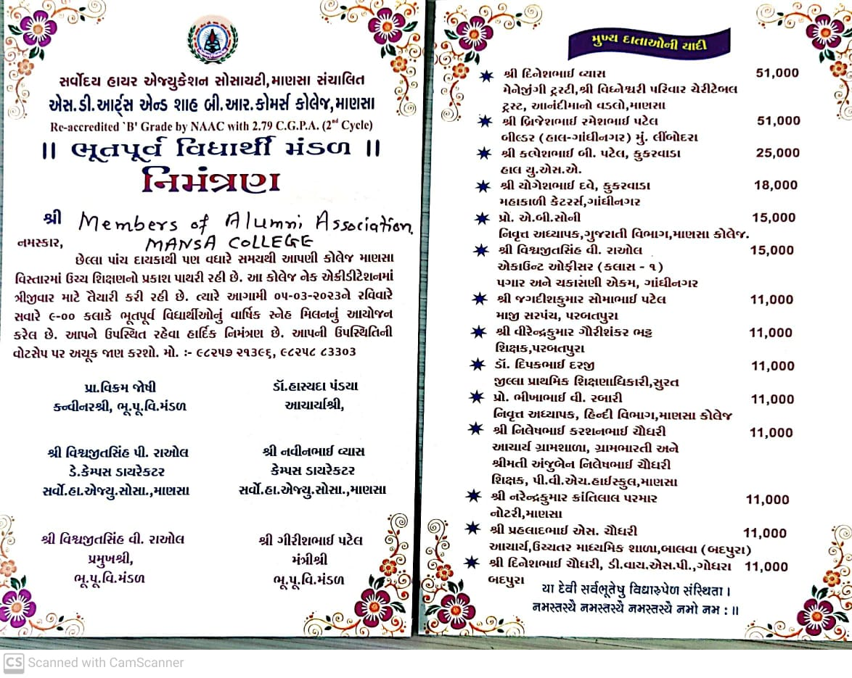

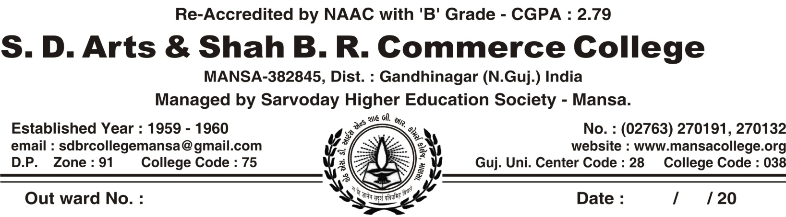

Alumni Annual Meet
(Program Design) Dt. 05/03/2023
1.) Recitation of Slokas : Prof. V.K. Joshi
2.) Lighting of the Lamp : by dignitaries on the dias
3.) Nomination of Dignitaries on Dias:
[1] Shri Vivekbhai Trivedi, - Chief Guest
[2] Shri Dineshbhai Vyas – Guest of Honour
[3] Shri Navinbhai Vyas – Campus Director
[4] Shri Vishvajitsinh P. Raol – Deputy Campus Director
[5] Shri Girishbhai Patel – Secretory, Alumni Association
[5] Dr. A.K. Patel, Vice-Principal, S.D.Arts & Shah B.R.Commerce College, Mansa

4.) Welcome Speech : by Dr. Hasyada Pandya (Audio Presentation)
Principal, S.D.Arts & Shah B.R.Commerce College, Mansa
4.) Introduction to NAAC : by Dr. A.K.Patel, Coordinator IQAC
5.) Essentials in NAAC : by Dr. Tushar Vyas, Joint Coordinator : IQAC
6.) (a) Felicitation for achieving Ph.D. degree :

[1] Dr. Twinkle Chaudhary – with shawl by Prof. D.S. Chaudhary
[2] Dr. Ramchandra Raol – with shawl by Dr. M.K. Patel
[3] Dr. Hemangini Prajapati – with shawl by Dr. Alkesh Trivedi
[4]Dr. Varsha Prajapati – with shawl by Dr. Sonal Prajapati
[5] Dr. Krunal Rana – with shawl by Dr. Krunal Rana
(b) Felicitation to Donars
[1] Shri Dineshbhai Vyas for donating Rs 51,000 – with shawl by Shri
Vishvajitsinh Raol
[2] Shri Narendrabhai Parmar – with shawl by Dr. M.K. Patel
[3] Shri Hiteshbhai Patel – Dr. T.J. Vyas
[4] Prof. S.G. Patel , Donar for Lunch – with shawl by Prof. V.K. Joshi
7.) Feedback / by the Alumni
8.) Anchoring & Vote of Thanks: by Prof. V.K.Joshi
Coordinator : Alumni Organization
9.) Meeting of Executive Committee of Alumni of the College for the discussion of Agendas and passing of the Resolution
* Lunch *

SARVODAYA HIGHER EDUCATION SOCIETY'S

S.D. Arts and Shah B.R.Com. College, Mansa

Alumni Meet Date: 5-3-2023

Alumni Meet was successfully organized today by Alumni committee. Mr. Vivek Trivedi was the chief guest of this function, while Dineshbhai Vyas, the social activist, Shree Navinbhai Vyas, Shree Vishvajitsinh Raol, Dr. A.K. Patel, Vice Principal chaired the dias. Shree Naveenbhai Vyas and Shree Vishvajitsinh Raol represented Sarovodaya Society, while Dr. Hasyada Pandya shared an Audio Message welcoming the Alumni. Dr. A.K. Patel explained the significance of institutional ranking. Dr. Tushar Vyas presented Vision and Mission of Sarvodaya Society for continuous institutional development. Shree Vivek Trivedi presided the function and Shree Dineshbhai Vyas generously offered help for Projector in making smart classrooms. Shree Shaileshbhai Patel, our professor and once upon a student, provided lunch. Our Alumni were honoured for their achievements in various fields.

And of course, extraordinary Anchoring was done by Prof. V.K. Joshi, the Convener of Alumni Meet. This program ended with vote of thanks by Prof. V.K. Joshi. There was Executive Committee meeting held on 5-3-2023 for discussion on agenda and passing of resolutions. All the members of Alumni and the teaching and non-teaching members of our institution had lunch together which was sponsored by Prof. S.G. Patel.

Alumni Association
Executive Committee Resolution
(5/3/2023)
In the meeting of Executive Committee held on 5/3/23, the following Resolutions have been passed with the consensus of the members of the body of Alumni Association.
- To organize programs for motivation of students.
- To help students in placement.
- To utilize the fund collected by Alumni Association for Educational purpose—for procurement of Educational Equipment in the making of Smart Classrooms.

Prof. V.K. Joshi Dr. Hasyada Pandya
(Coordinator: Alumni) Principal

Alumni Association – Executive Committee
Date: 5-3-2023
The following members of Executive committee were present in the meeting and gave their consensus for the resolution passed by the committee.

S.NO. | NAME | DESIGNATION | SIGNATURE
1. | Dr. H.B. Pandya, Principal | Chair Person
2. | Shri Vishwajitsinh V. Raol | President
3. | Shri Girishbhai Patel | Secretary
4. | Shri Vivekbhai Trivedi | Vice-President
5. | Shri Jigneshbhai Bhavsar | Joint Secretary
6. | Shri Ramchandrasinh Raol | Treasurer
7. | Shri Jayandrabhai K Jani | Member
8. | Shri Navinbhai Vyas | Campus Director
9. | Shri Vishwajitsinh P. Raol | Deputy Campus Director
10 | Retd. Prof. Bhikhabhai V. Rabari | Member
11 | Shri Mitalben Pandya | Member
12 | Shri Jaddishbhai S. Patel | Member
13. | Shri Rutesh Patel | Member
14. | Shri Hasmukhbhai Asodiya | Member
15. | Shri Manubhai Chaudhary | Member
16. | Shri Parmar Narendrabhai K. | Member
17. | Prof. V.K. Joshi | (Coordinator: Alumni)

Letter of Appreciation Date : 5-3-2023
The Annual Meeting of Alumni association of S.D. Arts and Shah B.R. Commerce College was held on 5-3-2023, Sunday, in which Prof. S.G. Patel, Head of Commerce Department in our college and our Alumnus, became donor for Lunch arranged for Alumni Meet. He was very fascinated by the activities carried out by the alumni association of our college. He understood the importance of Alumni association in NAAC accreditation process. The NAAC evaluates the activities of Alumni from the point of view of economical contribution and the how they are helpful in the development of students studying at present. Prof. S.G. Patel understood the need of Alumni Association of our college and very enthusiastically announced the donation of Rs 18800 to Alumni Association of our college. He also encouraged another Alumni to contribute to the Alumni Association of our college. We are very proud of such benevolent and kind Alumni of our college. We really appreciate his endeavor and the example he has set for other alumni. We are very thankful for his kind cooperation.

Prof. V.K. Joshi Dr. H.B. Pandya
Convener, Alumni Association Principal

Letter of Appreciation Date : 5-3-2023
The Annual Meeting of Alumni association of S.D. Arts and Shah B.R. Commerce College was held on 5-3-2023, Sunday, in which Shri Dineshbhai Vyas, The Managing Trustee of Anandi Ma no Vadlo, Mansa, was invited as the chief guest. He was very fascinated by the activities carried out by the alumni association of our college. He understood the importance of Alumni association in NAAC accreditation process. The NAAC evaluates the activities of Alumni from the point of view of economical contribution and the how they are helpful in the development of students studying at present. Our college management proposes to set up a Smart class. Shri Dineshbhai understood the need of our college and very enthusiastically announced the donation of a projector to Alumni Association of our college. He also encouraged another Alumni to contribute to the Alumni Association of our college. We are very proud of such benevolent and kind Alumni of our college. We really appreciate his endeavor and the example he has set for other alumni. We are very thankful for his kind cooperation.

Prof. V.K. Joshi Dr. H.B. Pandya
Convener, Alumni Association Principal

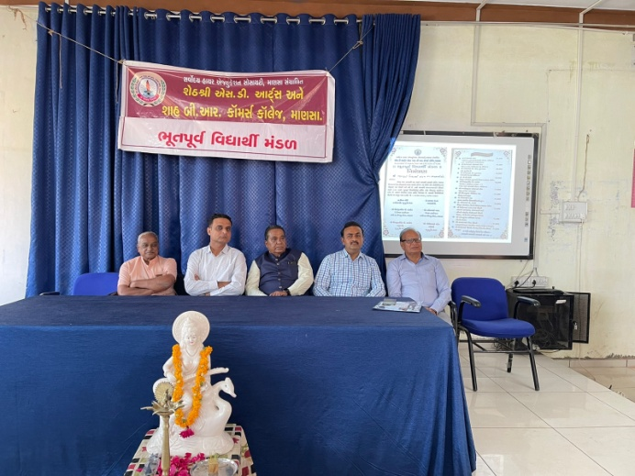 | 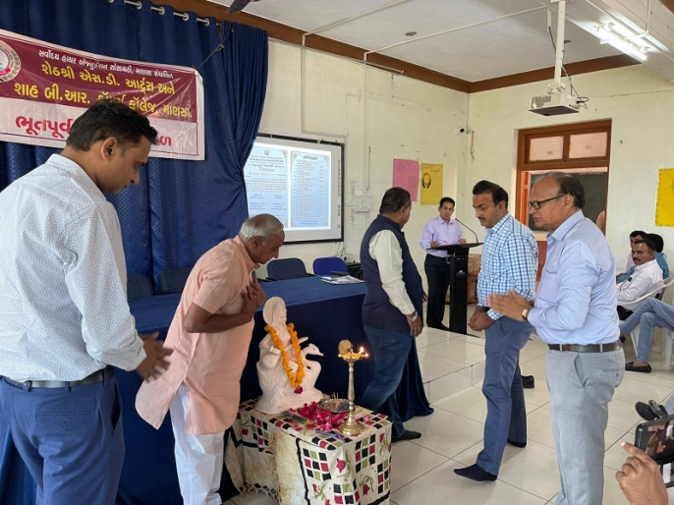
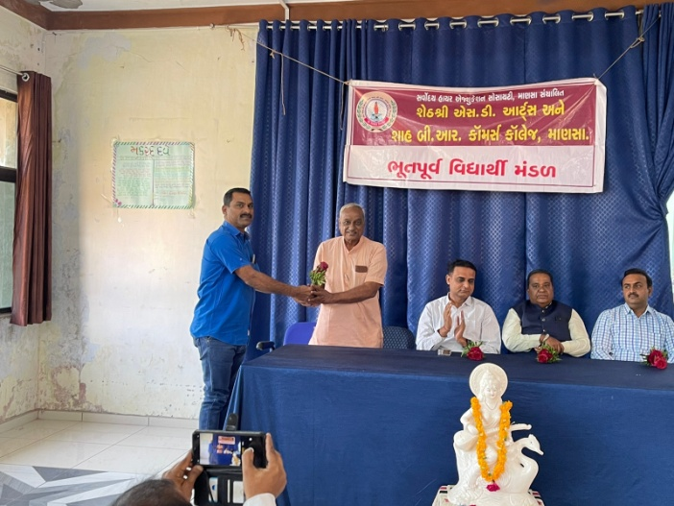 | 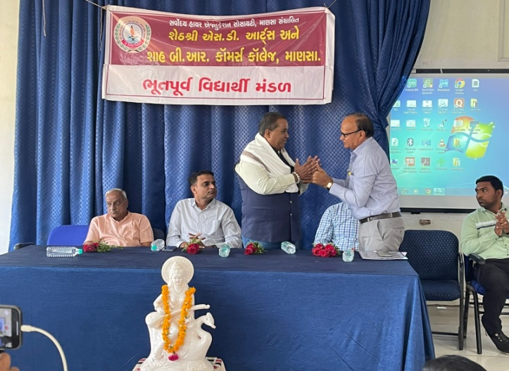
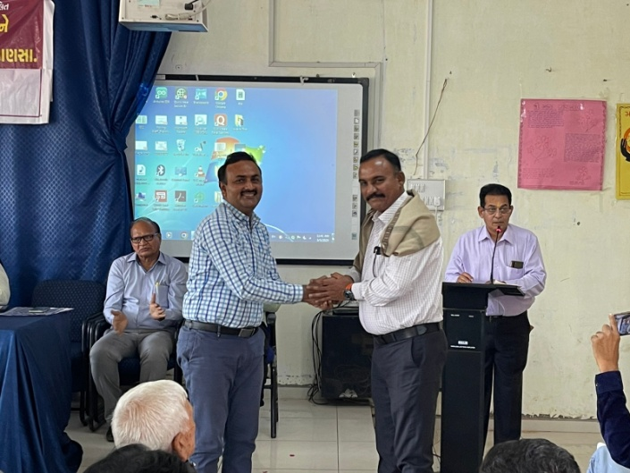 | 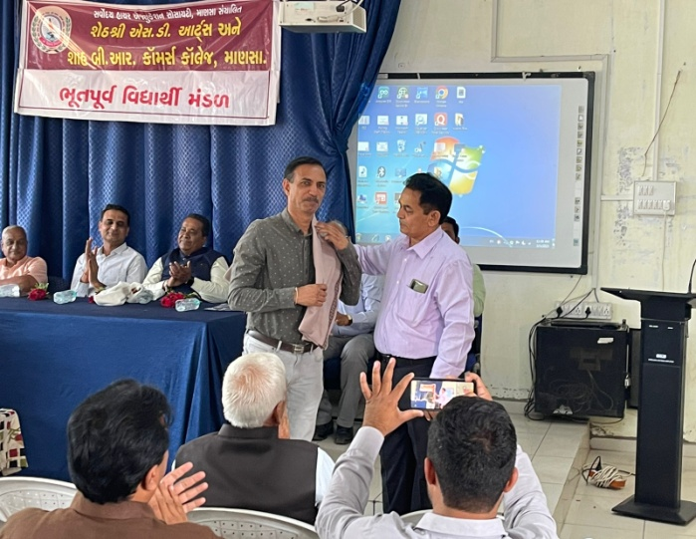
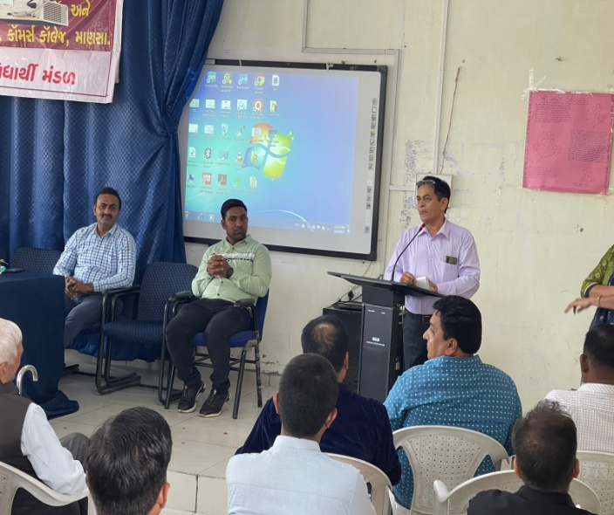 | 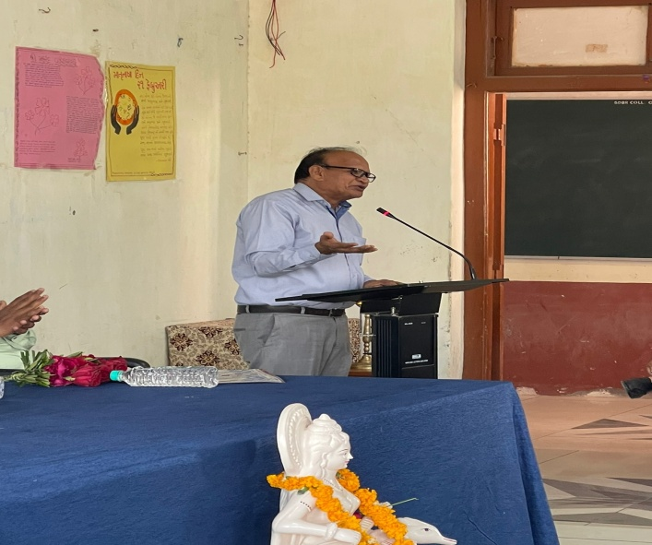
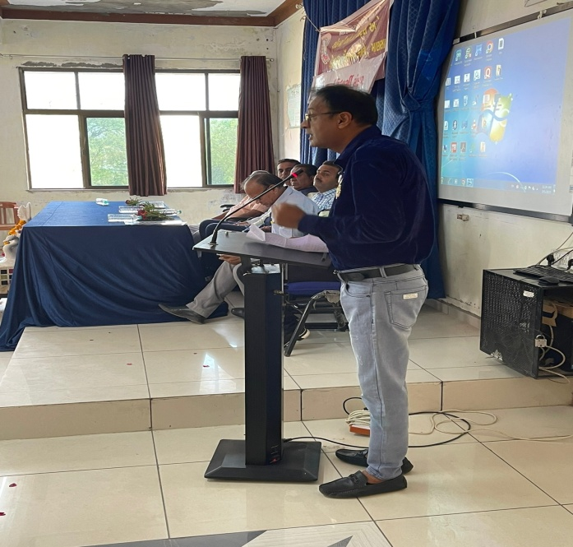 | 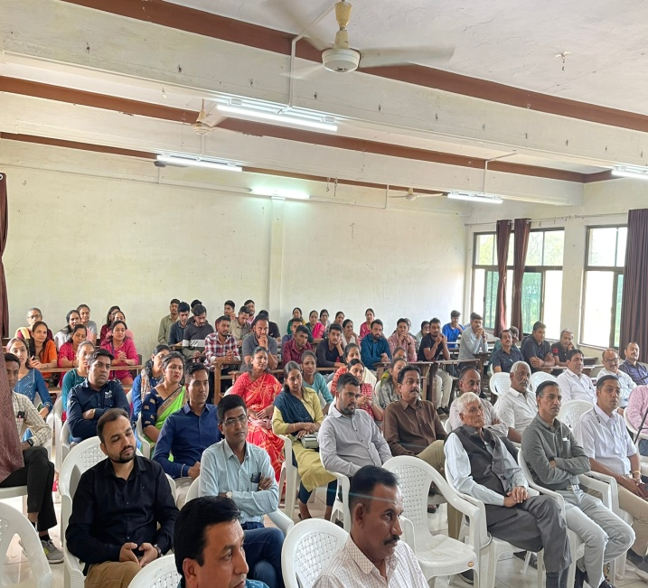
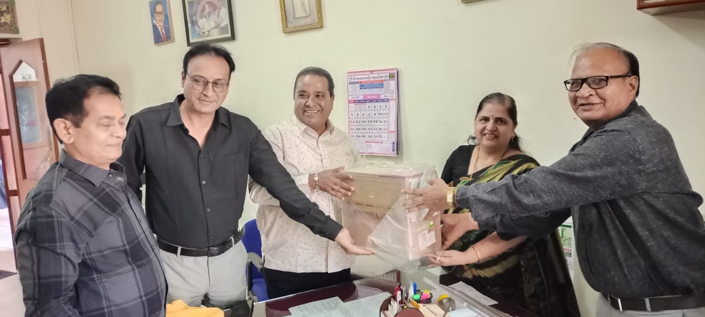 | 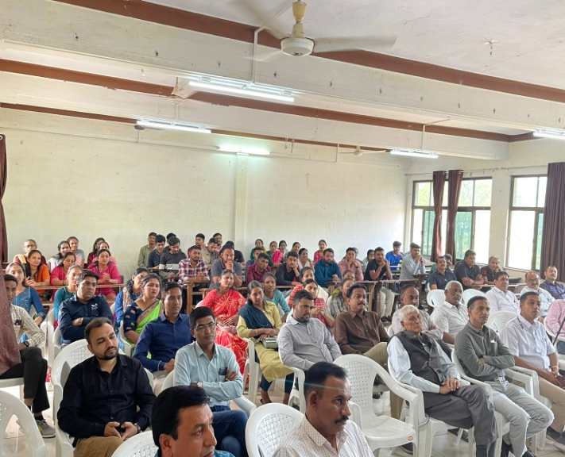

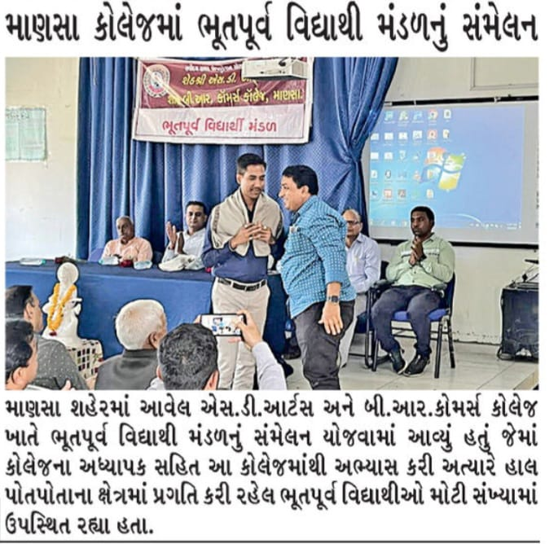

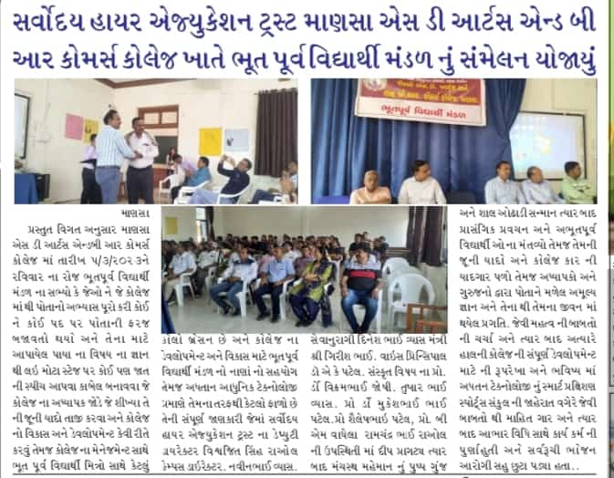

Manavmitra – Local Newspaper Date: 6/5-2023

