S.D. Arts and Shah B.R. Commerce College, Mansa
(Managed by Sarvodaya Higher Education Society)
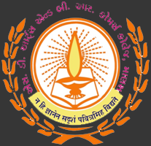
Short Term Course
on
‘English Literature and Language’
From 19/12/2022 to 29/12/2022
Organized by
English Department
S. D. Arts & Shah B. R. Commerce College, Mansa

Commencement of Short Term Certificate Course in English Department
The English Department of S. D. Arts and Shah B. R. Commerce College, Mansa, affiliated to Gujarat University and managed by Sarvoday Higher Education Society, Mansa, organized a short term course on “English Literature and Language” from 19/12/2022 to 29/12/2022. In the inaugural ceremony of this STC on 19 December, Res. Principal Dr. Hasyada Pandya conveyed the basic introduction of this course and explained the professional importance of English language and literature. Principal, furthermore, wished grand success to this program.
Head of English Department, Associate Professor Dr. A.K. Patel explained the detailed proceedings and schedule of the course. Five professors from this college joined in the course and enriched the students through their expert lectures. At the end, vote of thanks was delivered by Dr. B.M. Vaghela..
This course was inaugurated by our Principal Dr. H.B. Pandya, teaching staff of English Department and the participants on 19-12-2022. It was ten days course and timing was from 08.30 a.m. to 11.45 a.m. The lectures were taken by the faculty members of English department. The course was free of cost. The majority of participants were the students of English department and other departments of the college. They were in numbers and took part very enthusiastically and eagerly to learn the skills of English language.
This course ended on 29-12-2022 with certificate awarding function. The participants were given certificate with course schedule printed at the back of the certificate in valedictory function.

Dr. A. K. Patel Dr. Hasyada Pandya
Head, English Department Principal

Schedule
Sr. | Date | Time | Topic | Name of Resource Person
1. | 19/12/2022 | 8: 30 to 10: 00 | Inauguration  Introduction to English  Literature | Dr. T. J. Vyas
 |  | 10: 15 to 11: 45 |  | Dr. A. K. Patel
2. | 20/12/2022 | 8: 30 to 10: 00 | Foundation Studies in History  of English Literature | Dr. B. M. Vaghela
 |  | 10: 15 to 11: 45 |  | Dr. A. K. Patel
3. | 21/12/2022 | 8: 30 to 10: 00 | Foundation Studies in History of English Literature | Dr. A. K. Patel
 |  | 10: 15 to 11: 45 |  | Dr. U. C. Gor
4. | 22/12/2022 | 8: 30 to 10: 00 | Foundation Studies in Indian English Literature | Dr. B. M. Vaghela
 |  | 10: 15 to 11: 45 |  | Dr. T. J. Vyas
5. | 23/12/2022 | 8: 30 to 10: 00 | Introduction to Literary Criticism | Dr. U. C. Gor
 |  | 10: 15 to 11: 45 |  | Dr. T. J. Vyas
6. | 24/12/2022 | 8: 30 to 10: 00 | Introduction to Phonetics | Dr. A. K. Patel
 |  | 10: 15 to 11: 45 |  | Dr. T. J. Vyas
7. | 26/12/2022 | 8: 30 to 10: 00 | History of Indian English Literature : Pre-Independence Period | Dr. T. J. Vyas
 |  | 10: 15 to 11: 45 |  | Dr. B. M. Vaghela
8. | 27/12/2022 | 8: 30 to 10: 00 | Foundation Studies in Modern Literary Criticism | Dr. U. C. Gor
 |  | 10: 15 to 11: 45 |  | Dr. Alkesh Trivedi
9. | 28/12/2022 | 8: 30 to 10: 00 | Form of Literature – Novel | Dr. Alkesh Trivedi
 |  | 10: 15 to 11: 45 |  | Dr. U. C. Gor
10. | 29/12/2022 | 8: 30 to 10: 00 | Foundation Studies in History of Eng. Literature: Modern Age  Valedictory Function | Dr. Alkesh Trivedi
 |  | 10: 15 to 11: 45 |  | Dr. B. M. Vaghela

Glimpses of STC
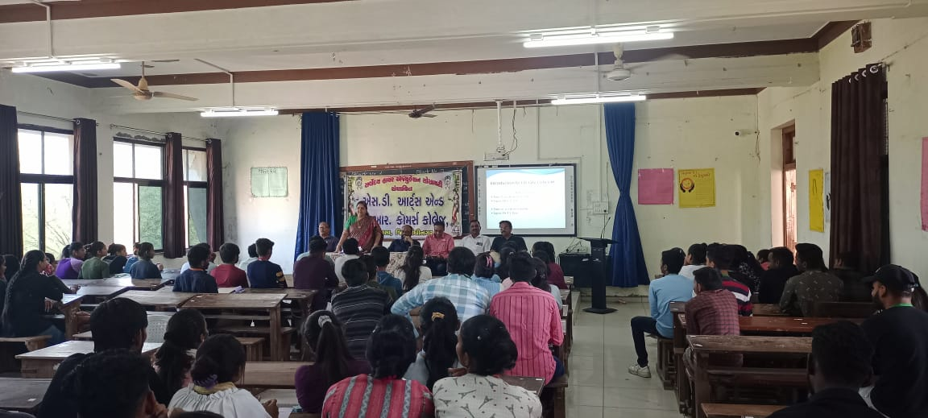 | 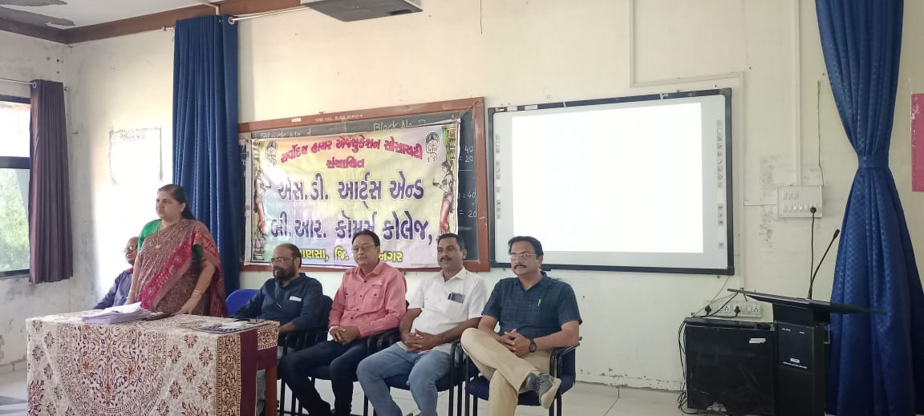
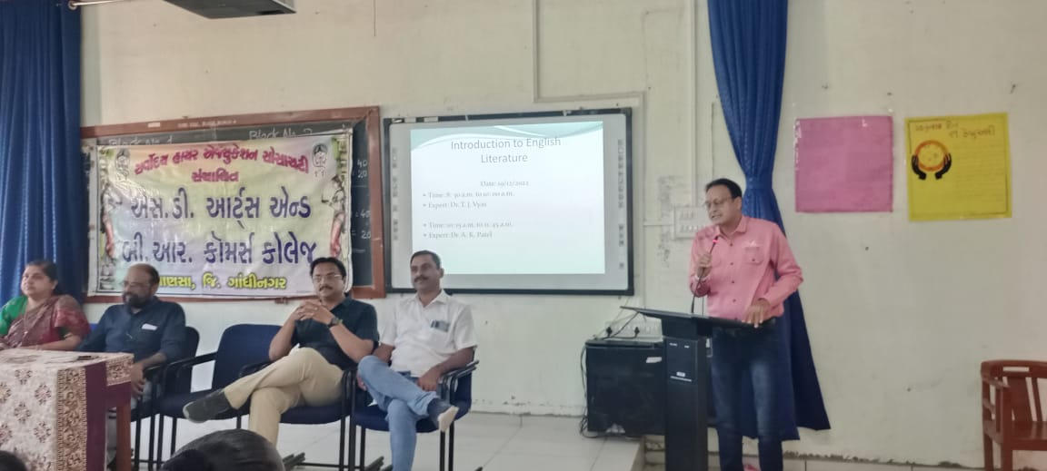 | 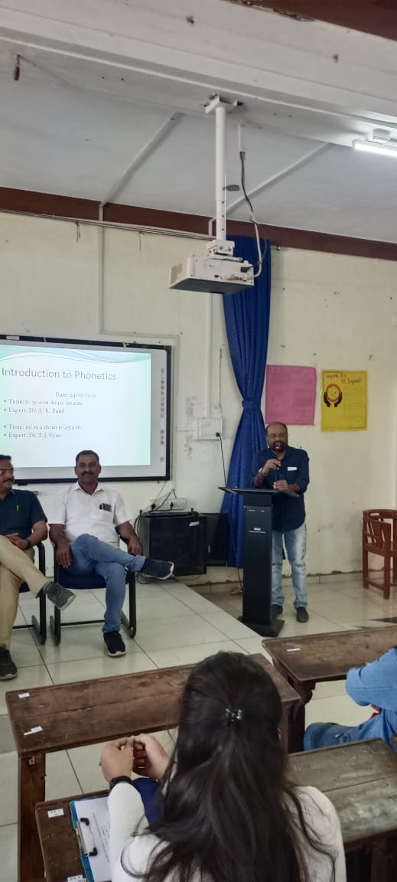
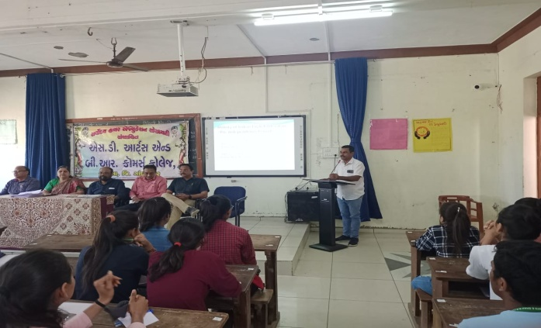 | 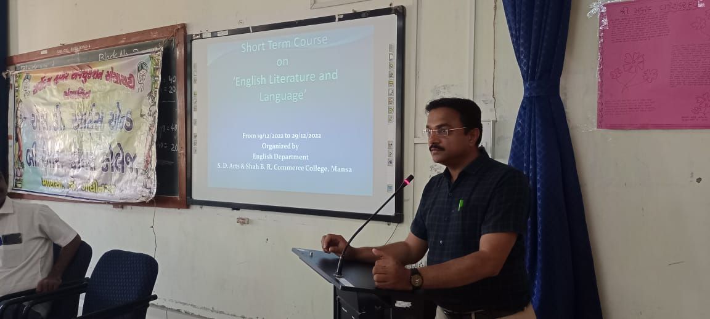
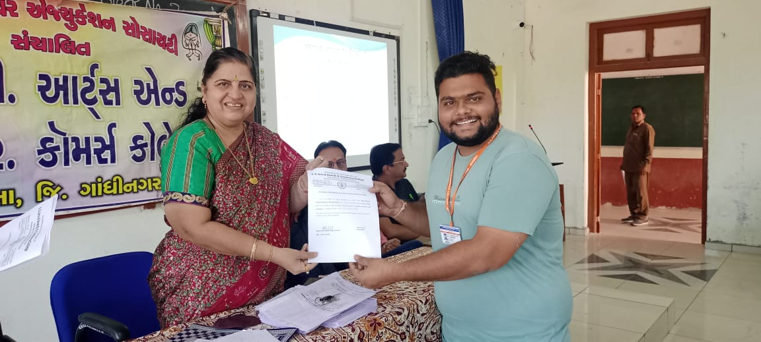 | 