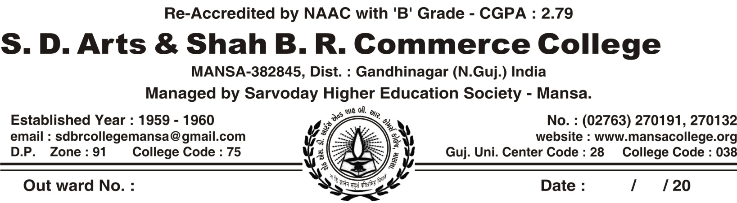

Meeting of Discipline Committee, Anti-Ragging Committee & Redressal Cell (Sem-1,3,5 -2018-19)

The Meeting of Discipline Committee, Anti-Ragging Committee, Redressal Cell was held on 10/07/2018 under the headship of our college principal Dr. H.B.Pandya. The committee passed the following resolutions in this meeting. All the members of this committee were present in the meeting. The following rules and regulations were resolved by the committee.

Rules and Regulations of the College Discipline Committee

- All students should reach the classroom on time and shall not leave the class without the permission of teacher.
- Students must regularly attend classes and exhibit decent behavior
- Students shall be abided by the rules and disciplinary actions taken by the discipline committee.
- Students are not permitted to engage in any kind of job during college hours. Moreover, the students must take prior permission of principal before accepting job proposal after college hours.
- Participation in intercollegiate programs within the city or outside is subject to permission of the principal.
- All students should wear identity card on their neck
- Student must park their vehicles only in the space allotted.
- Student found guilty of ragging will be dismissed from the college as per the Supreme Court’s ruling.
- Student shall keep themselves informed of the instructions issued to them time to time orally or through notices / circulars and emails.
- All students are requested to maintain the discipline at any cost in the classroom and on the campus.
- The principal shall be the final authority in the interpretation of the collage rules. Matters not covered by these rules are left to the discretion of the principal and committee and their decision shall be final.
- All the students will strictly follow the guideline of covid-19 pandemic.

Discipline Committee, Anti-Ragging Committee, Redressal Cell

S.No | Name of Members | Signature
1 | DR. H.B.Pandya- Chair Person
2 | Dr. M.K.Patel- Convener
3 | Dr. B. M. Vaghela - Member
4 | Prof. R.H.Raol- Member
5 | Prof. D.S.Chaudhary – Member
6 | Prof. H.B.Mehta- Member
7 | Prof. Rajesh Gavit -Member
8 | Shri.P.P.Gurkha-Watchman

Dr. M. K. Patel Dr. Hasyada Pandya
Convener Principal

Meeting of Discipline Committee, Anti-Ragging Committee & Redressal Cell (Sem-2,4,6 -2018-19)

The Meeting of Discipline Committee, Anti-Ragging Committee, Redressal Cell was held on 20/12/2018 under the headship of our college principal Dr. H.B.Pandya. The committee passed the following resolutions in this meeting. All the members of this committee were present in the meeting. The following rules and regulations were resolved by the committee.

Rules and Regulations of the College Discipline Committee

- All students should reach the classroom on time and shall not leave the class without the permission of teacher.
- Students must regularly attend classes and exhibit decent behavior
- Students shall be abided by the rules and disciplinary actions taken by the discipline committee.
- Students are not permitted to engage in any kind of job during college hours. Moreover, the students must take prior permission of principal before accepting job proposal after college hours.
- Participation in intercollegiate programs within the city or outside is subject to permission of the principal.
- All students should wear identity card on their neck
- Student must park their vehicles only in the space allotted.
- Student found guilty of ragging will be dismissed from the college as per the Supreme Court’s ruling.
- Student shall keep themselves informed of the instructions issued to them time to time orally or through notices / circulars and emails.
- All students are requested to maintain the discipline at any cost in the classroom and on the campus.
- The principal shall be the final authority in the interpretation of the collage rules. Matters not covered by these rules are left to the discretion of the principal and committee and their decision shall be final.
- All the students will strictly follow the guideline of covid-19 pandemic.

Discipline Committee, Anti-Ragging Committee, Redressal Cell

S.No | Name of Members | Signature
1 | DR. H.B.Pandya- Chair Person
2 | Dr. M.K.Patel- Convener
3 | Dr. B. M. Vaghela - Member
4 | Prof. R.H.Raol- Member
5 | Prof. D.S.Chaudhary – Member
6 | Prof. H.B.Mehta- Member
7 | Prof. Rajesh Gavit -Member
8 | Shri.P.P.Gurkha-Watchman

Dr. M. K. Patel Dr. Hasyada Pandya
Convener Principal

